AGSUP_ENDURANCE_CLEANUP

Job Link: http://jenkinsqant1:8080/view/Performance/job/AGSUP_ENDURANCE_CLEANUP/
Desc: Execute performance tests cleanup
Directory: [loadtestwt1/loadtestwt2] /home/devops/agsup-endurance
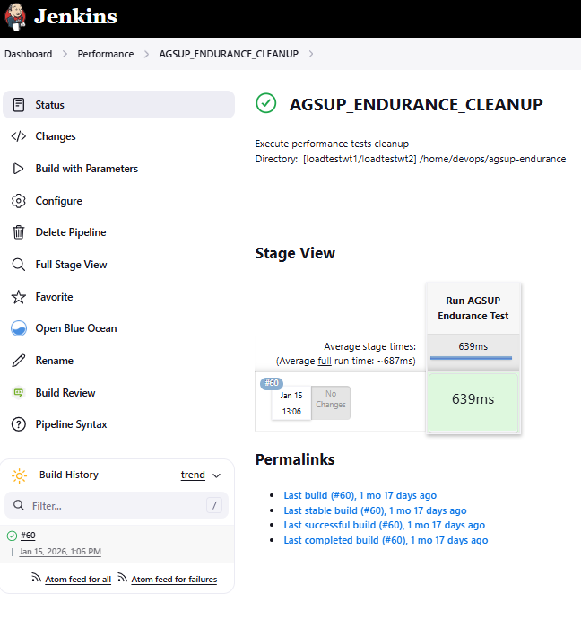
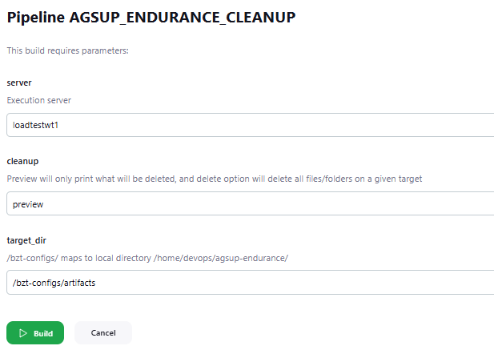

Config Desc:
Execute performance tests cleanup
Directory: [loadtestwt1/loadtestwt2] /home/devops/agsup-endurance

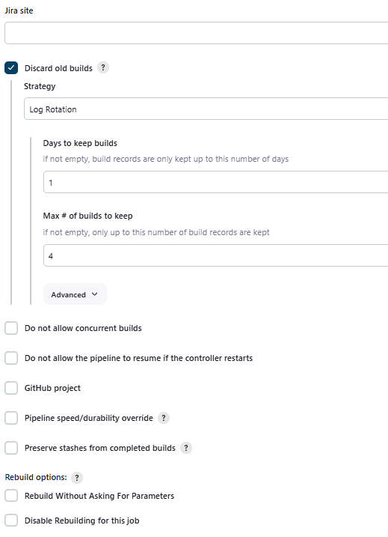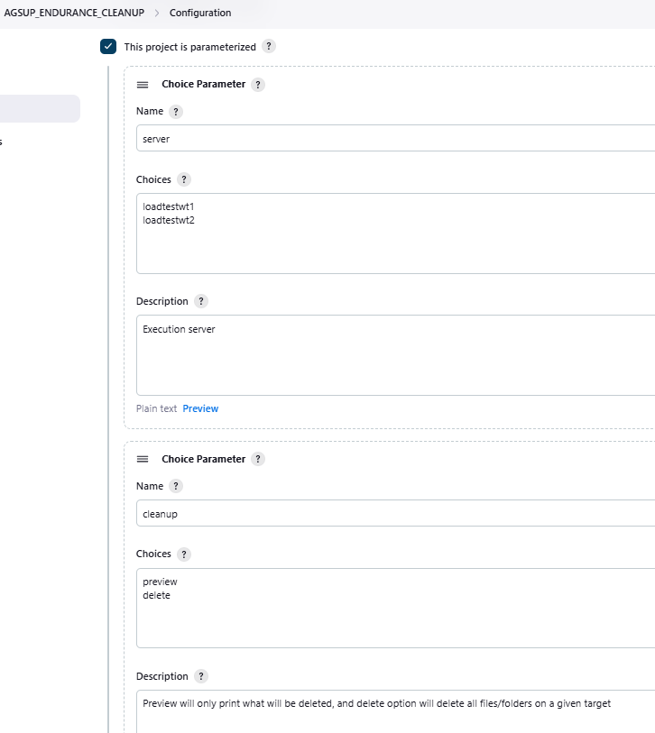
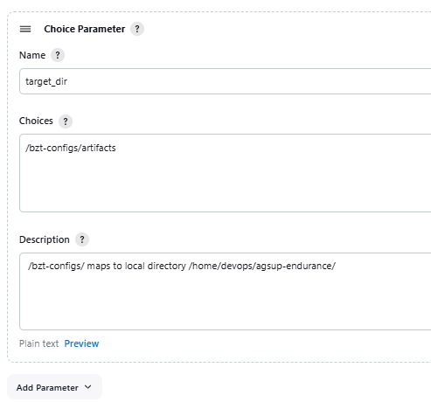

Pipeline:
stage('Run AGSUP Endurance Test ')
{
node("${server}")
{
cmd1= "cd /home/devops/agsup-endurance"
docker_run=""" docker run --rm \
-v /home/devops/agsup-endurance:/bzt-configs \
--entrypoint bash blazemeter/taurus/withplugins:latest \
-c "/root/bin/cleanup.sh ${target_dir} ${cleanup}" """
catchError(buildResult: 'FAILURE', stageResult: 'FAILURE'){
def cmd ="${cmd1};${docker_run};"
steps.sh script: cmd;
}
}
}

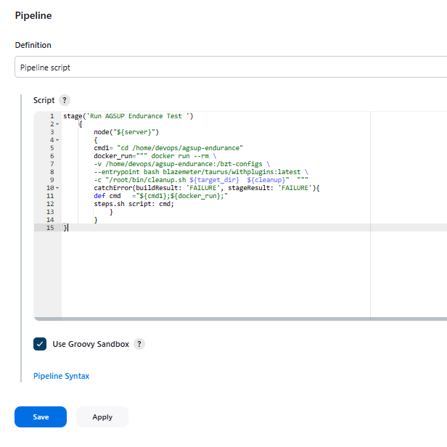

Job running output:
Console Output
Started by user qa_automation
[Pipeline] Start of Pipeline
[Pipeline] stage
[Pipeline] { (Run AGSUP Endurance Test )
[Pipeline] node
Running on loadtestwt2 in /home/devops/qajenkins/workspace/AGSUP_ENDURANCE_CLEANUP
[Pipeline] {
[Pipeline] catchError
[Pipeline] {
[Pipeline] sh
+ cd /home/devops/agsup-endurance
+ docker run --rm -v /home/devops/agsup-endurance:/bzt-configs --entrypoint bash blazemeter/taurus/withplugins:latest -c '/root/bin/cleanup.sh /bzt-configs/artifacts delete'
Target directory: /bzt-configs/artifacts
Action: delete
Deleting contents of /bzt-configs/artifacts...
Deletion complete.
[Pipeline] }
[Pipeline] // catchError
[Pipeline] }
[Pipeline] // node
[Pipeline] }
[Pipeline] // stage
[Pipeline] End of Pipeline
Finished: SUCCESS

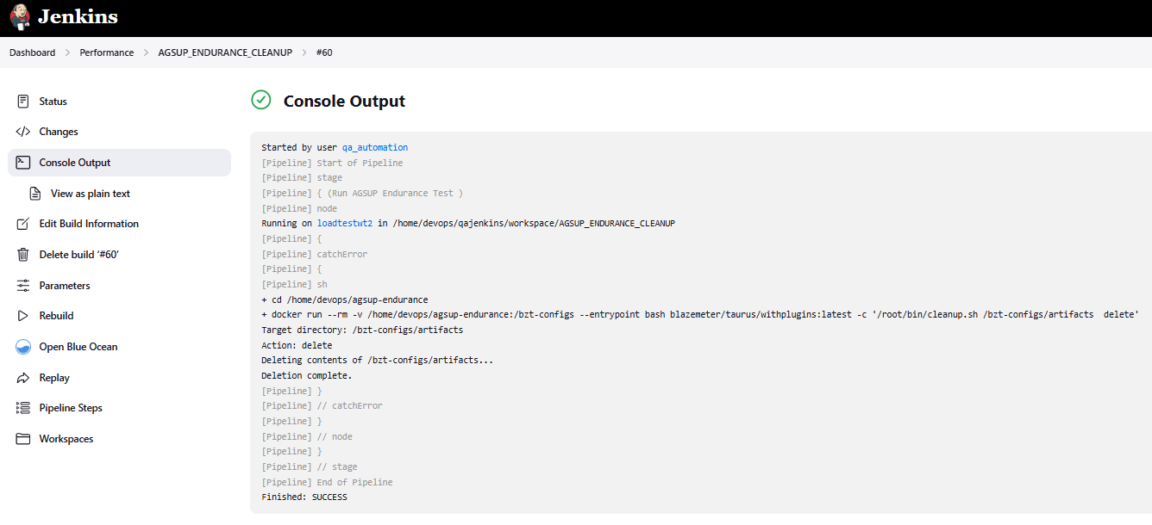

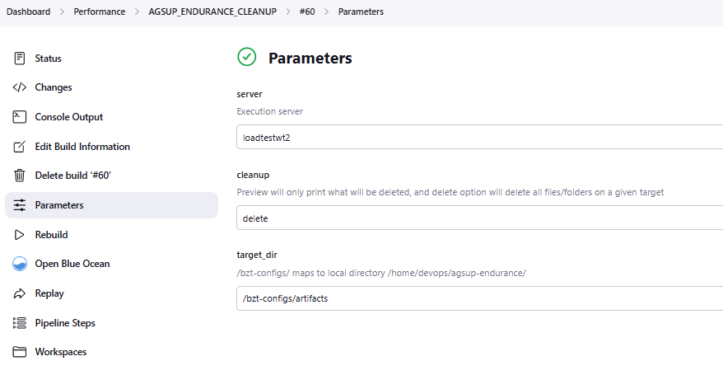
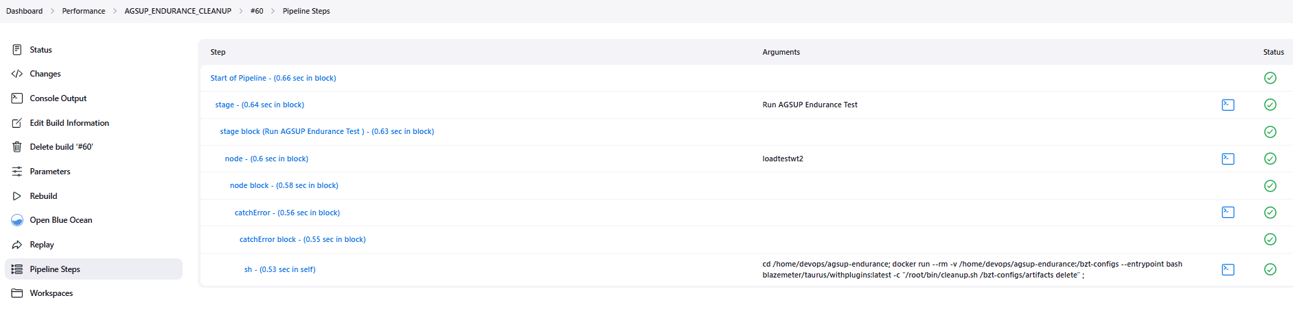

Workspaces for AGSUP_ENDURANCE_CLEANUP #60
- /home/devops/qajenkins/workspace/AGSUP_ENDURANCE_CLEANUP on loadtestwt2

